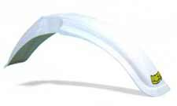

RAWBOLD 1ST CONNECTION POINT

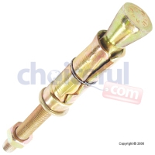

2ND CONNECTION POINT

